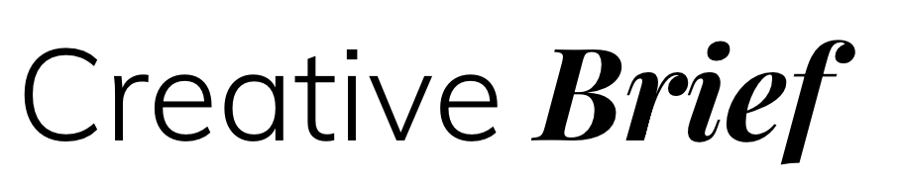

Thank you for taking the time to complete my creative brief document. It’s a great way for me to get to know your business, understand your audience and review your goals.

Your Information

Contact Name: xxxxx
Business Name: xxxxx
Business Tagline (optional): xxxxx

Existing website URL (optional): xxxx

Please email your existing logo (EPS file) or brand guidelines to hello@emmapaul.com.au

About your business
Introduction
Please provide a few paragraphs of information about your business.
E.g. products / services, brief history, size of business, your hero product or service etc.
xxxx
Please list 4 words that describe your business - tone, culture and values.
E.g. Corporate, creative, conservative, youthful, fun, quirky etc
xxxx

Target Audience
Who is the intended audience of your product / service?
Details of demographic E.g. age, income level, gender, geographic location etc
Xxxx
Imagine your ideal customer – Who are they, what personality traits do they have?
E.g. 45yrs female, only buys clothes online, time poor etc

Competitors
Who are your competitors either online or offline?
Please also provide their URL where possible
xxxx

Point of Difference
What are the main reasons a customer will choose your product/service over a competitor?
Xxxx

Visibility
How do people currently find your business/product?
Xxxx

Your new website
What do you hope to achieve with your new website? Please list any goals / objectives
E.g. showcase a product / service, make an on-the-spot booking, purchase something, increase newsletter subscribers etc
Xxxx
What is the main Call To Action for the home page?
For example, when a user visits your website home page, what action do you want to them to take next? E.g. Sign up for an account, View a full list of products, Make a booking etc
Xxxx

What content would you like on your home page?
Xxxx
Are there any websites you like that are similar to the look and feel you would like to create? Please list up to 5 URL’s and the things you like about each of them.
Xxxx

Suggestions / ideas you have for your new website.
xxxx

What colours / colour schemes do you like? (if different from logo)
xxxx

Are there any colours / concepts to avoid?
Xxxx

Do you have a specific launch date/period in mind?
Xxxx
Please add any further detail or instruction here:
xxxx

Your current website (if applicable)

What do you like about your current website? What works well?
xxxx
What do you dislike about your current website? Is there a single thing you dislike the most?
xxxx
Is there anything you hoped the website would achieve but didn’t?
Xxxx

Search Engine Visibility
Search terms
Please provide up to 10 search terms/phrases that you think people might type into Google, when looking for a business like yours e.g wedding singer in sydney
Xxxx

Sometimes a picture is worth 1000 words.
Please add any images that I should use for reference/inspiration/to help illustrate what you have in mind.

Your new Logo (if applicable)

Please tell me your ideas for your new logo:
Xxxx

What feeling or message should your new logo convey?
xxxx

What is your intended use for the logo?
E.g. website, brochures, food packaging, clothing labels etc
xxxx

Please supply images / URLs of any logos that are similar in style to what you have in mind, along with some text about why you like them:

Please add images and/or URLs here

Are there any fonts/typographies that you like? Please provide images or links.
Xxxx

What colours / colour schemes do you like?
Xxxx

Are there any concepts/styles to avoid?
Xxxx

Please add any further detail/instruction here:
xxxx

